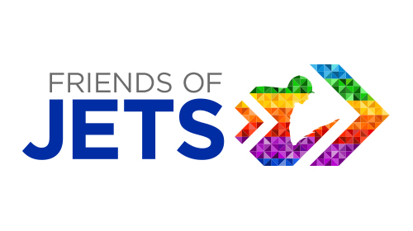
INFORMATION FOR POTENTIAL FRIENDS
Background
JETS does a brilliant job of advising jockeys and former jockeys on new career paths and giving them the skills, education and training backgrounds they need to develop new careers. However many jockeys struggle to find the practical opportunities to apply these skills in the workplace or indeed may like to seek specialist advise from someone they know is happy to give their time and understands the particular stresses and strains jockeys face when looking for a new career.
In order to broaden the network of support available, JETS has launched an initiative whereby we are inviting businesses and organisations both within horseracing and across other industries to become officially linked to JETS by providing careers supports specifically for jockeys and former jockeys – thereby becoming ‘Friends of JETS’.
What would being a FRIEND OF JETS entail?
- Provide specific points of contact within organisation who can answer queries/provide advice/offer contacts in their industry
- Offer placements/work experience week for jockeys and former jockeys
- Offer interview practice or other career guidance sessions (first come first served basis)
- Display Friends of JETS logo on website
- Reciprocal PR support
What benefits come from being a FRIEND OF JETS?
- Positive industry PR, especially given recent charity status of JETS
- Seen to be putting something back into the industry
- An additional expression of CSR
- Access to JETS candidates to support their business objectives
- Support with securing jockeys at corporate events
If your business is willing to support this initiative and help give jockeys a practical step up into a new career, please fill out the attached form and send it back to Lisa at JETS so that we can promote the relationship and make the JETS candidates we are dealing with aware of your business or organisation’s involvement.
CONTACTS:
Lisa Delany, JETS Manager T: 07919417462 E: lisa@jets-uk.org
Kate Struthers, PR & Marketing T: 07980661003 E: kate@jets-uk.org
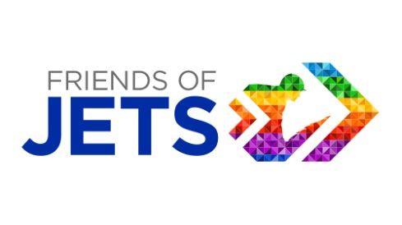
REGISTRATION FORM
BUSINESS/ORGANISATION NAME:
CONTACT NAME:
EMAIL: TEL:
Please fill in the areas of support you are willing to offer, this is really only for general guidance only and any arrangement would first be discussed with you and Lisa from JETS before anything was formally offered to a JETS candidate.
WEBSITE FEATURING FRIENDS OF JETS LOGO: YES/NO
(Please state website url that it will feature on:
CAREERS ADVICE POINT OF CONTACTS:
Individuals who would be willing to be contacted by JETS candidates looking for advice in particular areas e.g accounts, legal, administration, HR, racecourse operations, CV building
CAREERS CONTACT NAME:  TEL:  EMAIL:  AREAS OF EXPERTISE: | CAREERS CONTACT NAME:  TEL:  EMAIL:  AREAS OF EXPERTISE:

CAREERS SUPPORT: Please indicate any of the following that in theory you would be happy to offer jockeys or former jockeys to help them with their future careers:
Work Placements Y/N Interview Practice Y/N
Work Experience ‘taster’ day/week Y/N Career Guidance Sessions Y/N
Other (please specify):
SOCIAL MEDIA & PR SUPPORT: Y/N
#friendsofJETS mentions, links to website to help promote the initiative and attract further FRIENDS
SIGNED:
NAME: DATE:
Please return this form along with your business logo to Lisa Delany (lisa@jets-uk.org) so we have a record of your participation. We can then announce your participation on our website.

